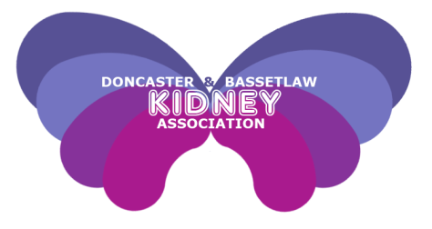

Newsletter

* 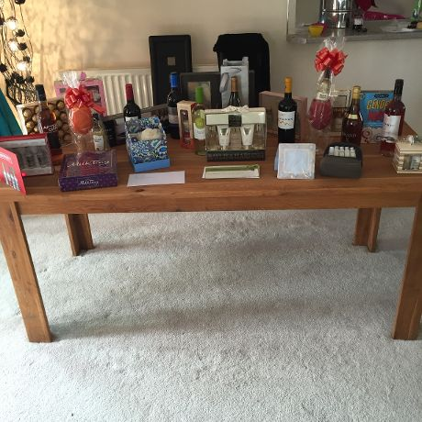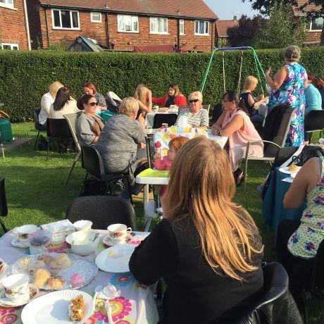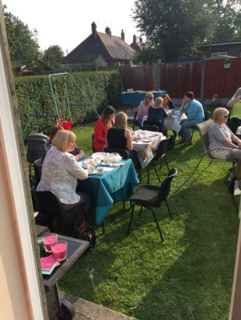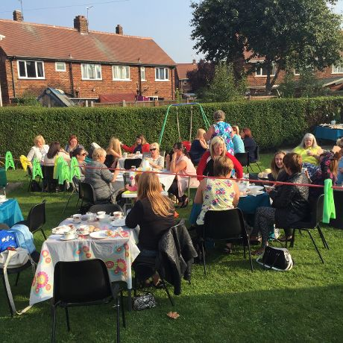

Christine Ross whose son-in-law is a HD patient in Doncaster Renal Unit was happy but surprised about all the different fundraising opportunities for other long term conditions and decided she wanted to do something original to support DABKA.

Christine arranged an afternoon tea with all her family and friends and asked for anyone who wanted to bake to bring their goodies along. Christine funded the food from her own money and asked everyone to donate £7.50 to attend and also to bring along a raffle prize.

Thankfully the weather was good to them and Christine held it out in her back garden. 28 family and friends turned out for the day and many other friends who were unable to attend sent money and raffle prizes. Games of bingo were played where half of the money was given back as prizes and the other half was added into the collection. Christine & her guests decided on the day that they had it enjoyed it so much it would become a yearly event!

And a grand total of £433.39 was raised. A BIG THANKYOU to Christine for hosting such a well-attended event and for your support to DABKA.

***Emma Ross***

.

Afternoon Tea success!

**Doncaster & Bassetlaw Kidney Association would like to wish everyone a peaceful Christmas and all the best for 2016**

**Dates for your diary**

DaBKA are hosting a ***Winter wonderland auction & Dinner*** Saturday 21st November please see page 4

***DaBKA’s Christmas Party*** will be held on Sunday 6th December at the Keepmoat Stadium, Doncaster, please see page 8 for full details

***DaBKA Christmas cards* and raffle tickets** are now on sale in Doncaster Royal Infirmary Renal Unit, Dearne Valley and Bassetlaw Dialysis Units, please see page 10 for further info

Doncaster & Bassetlaw Kidney Association

www.dabka.org.uk

Registered Charity Number 1123780

DVDU Trip to Skegness 2

Auction Night 3

DaBKA’s new committee 4

Townfield Gala Review 8

Contact details 24

Inside this issue:

**Dearne Valley (Mexborough) Dialysis Unit trip to Skegness**

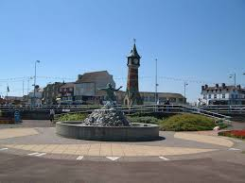What a wonderful day....the annual trip from Mexborough dialysis unit to Skegness on Sunday 30th August.

A total of 45 patients, family and friends made the journey. A varied day - a walk on the

pier, fish and chip lunch, a classic car exhibition and a live jazz band in the park, all packed in to 4

hours. Even Bingo was played on the bus!! - the grand sum of £10 raised to add to DABKA funds.

The day was enjoyed by all - the only complaint being that the time in Skegness was not long

enough!

**David Alderman**

**Asda presentation to DaBKA**

During August and September this year, we were fortunate enough to have our nomination put forward for the green token collection against two other local charities. I am pleased to tell you DaBKA was the winning charity, collecting a cheque for £200, which was presented to Mary and myself on behalf of Dabka at the beginning of October by one of the Community Champions staff at the Bawtry Road store.

This will be a great boost - not only to our fundraising efforts, but also in raising our profile in the community.

With that in mind, DaBKA has recently teamed up with the staff at the Thorne branch of Natwest bank to run a month long sponsored event again to raise awareness of our charity and the work we do and to encourage people to sign up to the organ donation register. The bank staff have each chosen a different task to be sponsored for throughout November, with a small raffle and some merchandising items on sale.

We wish them every success and will report on their results in the next newsletter.

Please see the opposite page for photos of the Asda presentation and Natwest Thorne event.

**Mary & Andy Wraith**

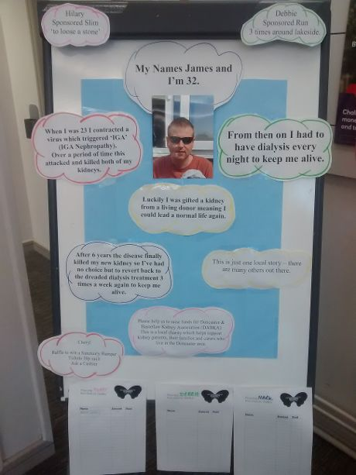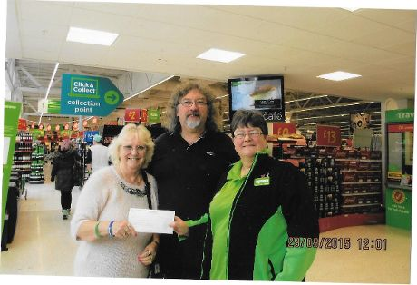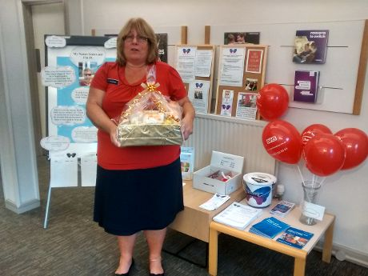

Photographs of the Natwest Thorne Branch

Pictured above: Asda representative from the Bawtry Road Store, presenting a cheque for £200 to Mary & Andy Wraith

**Auction Night – Saturday 21st November 2015**

Do you fancy a great night out with your friends? Begin the festive season in style! DaBKA proudly presents A Winter Wonderland Charity Auction Night, sponsored by Pacy & Wheatley

You will:

* Indulge in a 3 course meal
* Experience an evening of great company with special guests Gavin & Jamie McDonnell taking part in a 30 minute Q & A session
* Have the opportunity to bid on some fantastic auction lots
* DJ & Disco
* Bar open till 1am

Formal Wear

£35 per head, £320 per table of ten

Come and join us for a great night!

For further information or to purchase tickets, please contact Phil Smith on 0750 600 5199 or email [philsmith@dabka.org.uk](mailto:philsmith@dabka.org.uk) or to bid on items please visit www.dabka.org.uk



**Taking a holiday on Dialysis**

Hi,

My name is (Francis) David Alderson and I've been a haemodialysis patient at the Dearne Valley

Dialysis Unit, Mexborough, since October 2014.

My dialysis started after an operation last October to remove my left kidney and followed on from 8 years of reducing kidney function. During the recovery period after my operation I thought I would never be able to go on holiday again - needing dialysis 3 times per week

( Tues/Thurs/Sat ) where could I possibly go on holiday? But, as I got more used to the routine of dialysis and my body got used to dialysing and, as I got stronger, I began to realise that I could go on holiday again.

So I did my research and found that there are plenty of dialysis units dotted around the country, including a dialysis unit in Wells next the sea, North Norfolk i.e.: The Mermaid Centre at Wells Community Hospital- only 5 mile away from a cottage we used before I started dialysis. It took only a few phone calls for me to book the dialysis and the cottage for the same week and then it was left to my dialysis unit and the unit in Wells to liaise with each other with regard the details. Our holiday actually took place Fri 18th Sept to 25th Sept and, with trepidation, I went for my first dialysis session on the Saturday morning.

I needn't have worried. The staff at the unit were very kind, caring and understanding and my 3 sessions went well. I would definitely recommend the unit without any reservations.

When I did my initial research to find holiday dialysis units I also found that a new unit had opened in Alnwick, Northumberland - only 10 miles from a cottage we've used before. So, the cottage and the dialysis unit are also booked for one week next May.

So, from thinking I would never go on holiday again here I am, having had one holiday and another one booked for next year.

What of the future? Many more holidays to come for as long as possible...

Useful sources/information that I have found useful for holiday dialysis:-

The British Kidney Patient Association - www.britishkidney-pa.co.uk

The National Kidney Federation - www.kidney.org.uk

Renal Services UK - www.renalservices.com

Fresenius Medical Care - [www.freseniusmedicalcare.co.uk](http://www.freseniusmedicalcare.co.uk)

**David Alderman**

**Finance**

**By Christine Spyve**

**Infrared Therapy Unit Appeal**

We launched our new appeal earlier in the year and have already reached our target thanks to the following donations:

Hallcross Masonic Lodge - £1,500

Yorkshire West Riding Masons matched the donation - £1,500

Mrs TL Kent - £1,000

The ladies of Owston PCC - £360

Connells Fair - £50

Mr & Mrs Gow - £10

Mrs Wyn Hibbard - £10

**Summer Gala**

We also held our most successful Summer Gala on Town Field in July raising a total of £2,468.23

Stall Holders - £1,275.00

Raffle – £796.00

Tombola - £230.80

Football tournament - £131.43

Saskia’s Sweets - £12.00

Sale of Pens etc - £23.00

**Other Fundraising and Donations**

Asda Doncaster Token scheme - £200

Warmsworth pudding Club - £100

J & DC Knott - £165

Sale of donated Wheelchair - £100

Mr N Woodward - £30

Sale of Pens - £78.50

Sale of Wristbands - £78

DRI - Sale of Handmade cards - £4.00

DRI – Sale of Rob’s CD - £4.00

DRI – DRI Sale of Books - £2.00

Thank you to everyone who sent in scanner donations with their Summer Raffle Draw

tickets, it is very much appreciated.

**Finance continued**

Sadly, some of the donations we receive are from those who have lost loved ones and are sent in lieu of flowers and in memory of someone special. Over £ 1000 has been received in memory of the following:

James Fenwick

Edie Sullivan

Stan Woods

Gerald Moore

MCN Kelk

Ivor Brumpton

Anon

*We would like to send all family and friends our condolences and thank them for thinking of others at such a sad time.*

***Thanks go to everyone who has worked so hard in helping to raise funds for DaBKA, it is very much appreciated.***

**___________________________________________________________________________**

**This year, DaBKA launched an appeal to purchase a Far Infrared Therapy Unit.** The cost of the unit is approximately £4,500. Due to the tremendous success of this appeal, DaBKA are aiming to provide an Infrared Therapy Unit at each of the sites, Doncaster Royal Infirmary, Bassetlaw Dialysis Unit at Worksop and Dearne Valley Dialysis at Mexborough.

Doncaster Royal Infirmary Renal Unit has had a Far Infrared Therapy Unit on trial for 3 months. Patients have reported reduced pain in their fistulas during dialysis and that is very popular.

The benefits of the Far Infrared Therapy Unit to patients are:

* + - It can help relieve pain in fistula arms
    - It helps improve access blood flow that enhance dialysis efficiency
    - With long term use can improve the survival of vascular access (AV Fistula or AV Graft)
    - Reduced vascular access complication related to surgery
    - It is user friendly and safe
    - Helps improve the quality of dialysis sessions



Dabka christmas party!

Sunday 6th December  
5pm to 8pm

Doncaster Keepmoat Stadium, DN4 5JW

Please join us for our Annual Christmas Party.

Meet fellow patients, have a chat,

a bit of fun and enjoy a festive buffet.

**DaBKA members and renal patients are free, non-members are £5 each.**

*Easy disabled access and disabled parking available*

*All places must be booked.*

Please fill in the form attached to this newsletter, call or text Denise

on 07444 281 141 or email [admin@dabka.org.uk](mailto:admin@dabka.org.uk)

to book your place We look forward to seeing you!

**Christmas Raffle 2015**

Tickets are on sale in the renal units for £1 each. The raffle will be drawn at the Christmas party on Sunday 6th December. The prizes are as follows:

1st: £100

2nd: £75

3rd: Luxury Christmas Hamper

Plus lots of other prizes!

**This puzzle is just for fun!**

Add a letter:

The answers to these nine clues are five-letter words and each one consists of the four letter word given, but with a letter added. Write just this letter into the empty box. Solve all nine clues and the added letters, in order, will spell out a nine-letter word.

(answer is on the last page)

|  |  |  |
| --- | --- | --- |
| MALE |  | Canadian Tree |
| GILT |  | Sleeveless Jacket |
| THEE |  | Low number |
| EVER |  | High temperature |
| VOID |  | Egg-shaped |
| HOSE |  | Stallion or mare |
| OWED |  | Cut grass |
| WILD |  | Exert influence |
| ALLY |  | Car Race |

**Christmas Cards - £3.50 per pack of 10**

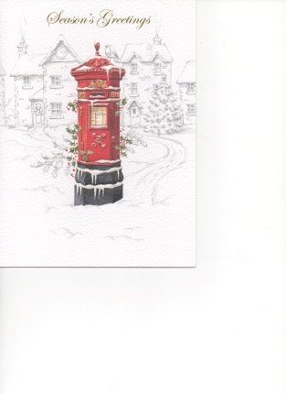Pure Illustration 00010698GR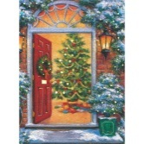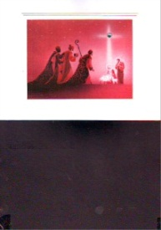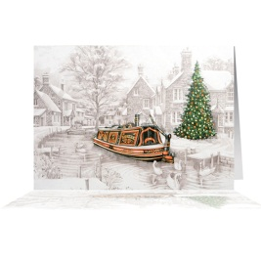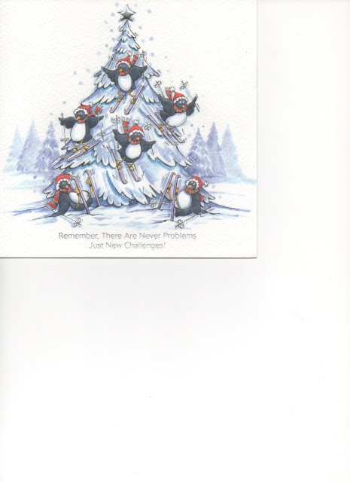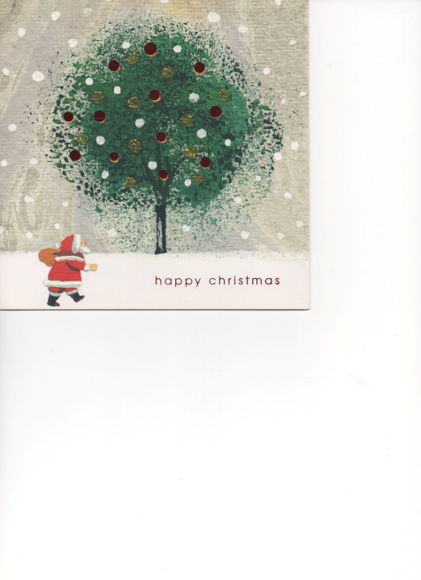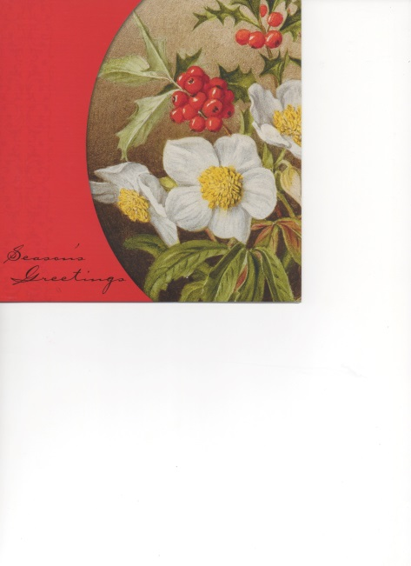1N226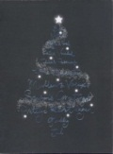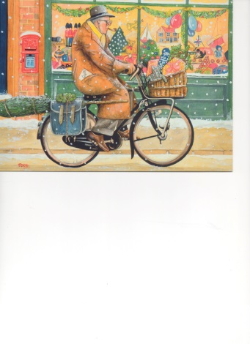

These excellent quality Christmas Cards are on sale now in your local renal unit or please get in touch with us on 07444 281 141 or email [admin@dabka.org.uk](mailto:admin@dabka.org.uk). Mixed packs are also available

The Magic

Penguins Skiing

Santa’s Journey

Christmas Rose

Icy Snowflakes

Snowman and Robin

Winter’s Lane

Village in Winter

Baa Humbug

Star Spangled

Village Post

The Open Door

Winter Mooring

Grandad is Coming for Christmas

Square cards measure approx. 160mm x 160mm (6.5 ins x 6.5 ins)

Oblong cards measure approx. 200mm x 150mm (8 ins x 6 ins)

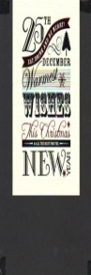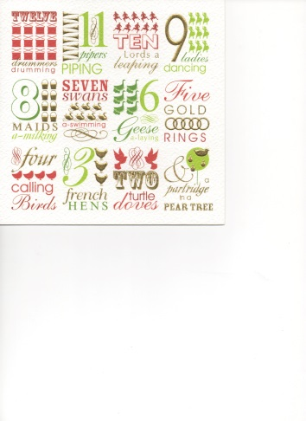

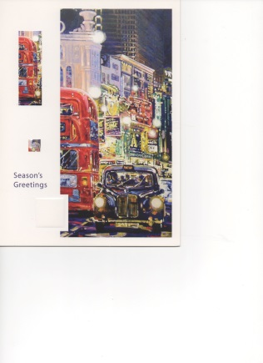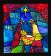

Finishing Touches

12 Days

Wake me up when it’s all over

Silent Night

Winter Games

Baubles and Stars

Christmas Calligraphy

A Winter Drive

Christmas in the City

Teamwork

Be Merry

Stained Glass Nativity

Cracking Team

Spiral Tree

Frosty Holly

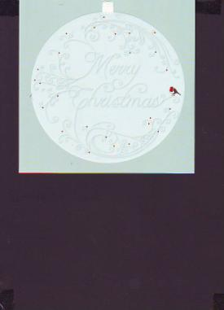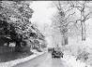 **Low Phosphate, Low Potassium Mincemeat Muffins**

**MC900048733[1]**

**Method**

1. Pre-heat the oven to 200°C, 400° F, Gas Mark 6.
2. Sift the flour & baking powder into a large bowl.
3. In a separate bowl, beat the eggs, orange zest & milk.
4. Stir the melted margarine into the milk mixture and pour into the flour mixture.
5. Stir gently with a large metal spoon until the mixture is lumpy and not all stirred in.
6. Spoon ½ the mixture into muffin cases, then add a teaspoon of mincemeat to each & cover with the rest of the mixture.
7. Bake in the oven for about 25-30 minutes, or until risen & golden.

Then leave to settle for 2 minutes before removing from the tins.

Enjoy!

**Mincemeat Muffins (Makes 12)**

**Ingredients**

250g (10oz) plain wholemeal flour

15ml (3 teaspoons) baking powder

2 large eggs

zest of 1 orange

175ml (6fl oz) semi-skimmed/skimmed milk

75g (3oz) margarine (melted)

60ml (12 teaspoons) mincemeat

Keeping to a low phosphate, low potassium diet as well as sticking to fluid restrictions can be difficult and particularly hard around Christmas time.

Our renal dietician team have recommended this recipe as a delicious alternative to Mince Pies. If you have any queries about your diet, please speak to a member of your renal team.

**Updates from the National Kidney Federation**

The NKF has had two major successes regarding issues recently reported on at The NKF Annual Conference, in Kidney Life magazine and IN Touch

**Commissioning Dialysis Services** The threat of Dialysis Services being commissioned by CCG’s instead of centrally by NHS England has receded. Following a long and hard fought battle waged by the NKF for over a year and involving KPA’s we are pleased to report that NHS England has now published “Improving Value for patients from Specialised Care” – Commissioning intentions 2016/2017 for prescribed Specialised Services NKF is relieved to see that there are no wholesale plans to remove Kidney Dialysis from the Specialised Commissioning stable – so from that point of view this is an NKF victory. Even Co-commissioning is not proposed, although there is some experimentation with Collaborative commissioning where Dialysis remains centrally commissioned but in co-operation with CCG’s. It should be noted that NHS England (the central commissioners) now splits its work into National, Regional and Sub regional levels. Changes that will go ahead are as follows:-

1. Renal in London will be Collaboratively Commissioned across the whole care pathway

2. Data is being collected to high light service variations in Renal dialysis by Public Health England

3. Some renal services will be commissioned via evaluation schemes

4. Renal Transplant is to have a national Tariff

5. Collaborative Commissioning for Renal Dialysis will be proposed where there are links to Obesity and diabetes in an attempt to increase prevention across the CKD pathway

NKF is very pleased with this, as we seem to have prevented the downgrading of Dialysis from level one commissioning to level three commissioning. The changes that are being proposed make a lot of sense, and as London is a region in its own right (Under the NHS England new tier structure) what is now proposed is logical.

**Cuts to the Dialysis Tariff**

At a meeting with MONITOR on 21st October 2015 the threat to make swinging cuts to the Dialysis Tariff also receded – instead it was understood that the existing Tariff will be “rolled over” to next year – this also followed extensive campaigning by the NKF. The meeting further agreed that to ensure that the Tariff was fit for purpose in future years the following work would be undertaken :-

* Identifying a reference cost baseline
* Involving a ‘working group’ of stakeholders which can reflect the holistic patient pathway and the inherent patient support services of the MDT
* Incentivising Home Dialysis
* And assessing the BPT

The NKF believes this to be a sensible approach and is very pleased at this outcome NKF thanks the All Party Parliamentary Kidney Group who supported the NKF in both campaigns.

**British Kidney Patient Association Grants**

The BKPA provide grants for kidney patients

They can help with the cost of domestic bills such as car insurance and tax, heating costs, telephone installations, and TV licenses. They may also help with the purchase of domestic goods like washing machines and carpets.

They also give grants to families and individuals towards the cost of a basic holiday in the UK or overseas. The grant can be used to cover the total cost if modest, or or it can be used as a contribution to the final cost of the holiday.

Grants are also available for education and training and also some travel costs.

There are conditions and limitations attached to the grants and application forms will need to be signed by your medical team.

A full list of grants offered can be found at [www.britishkidney-pa.co.uk,or](http://www.britishkidney-pa.co.uk,or) by calling 01420 472 021.

**British Kidney Patient Association -**

**Support Phone Line**

The British Kidney Patient Association have set up a support phone line service.

For units like ours without counselling services, this gives kidney patients a chance to talk to an experienced counsellor during challenging times.

Jacquie Fraser is available via phone and email from the BKPA offices every Tuesday and she will listen and provide appropriate support.

In her capacity as a support worker, she’ll also be able to guide patients with personal grant appalication to the BKPA where there is no social worker on site.

Contact Jackie on 01420 541 424 or

via email at [jacquie.fraser@britshkidney-pa.co.uk](mailto:jacquie.fraser@britshkidney-pa.co.uk)

*If you are having difficulties, please remember, you can always speak to a member of your renal team or your family GP.*

**Free blood pressure monitor for local patients**

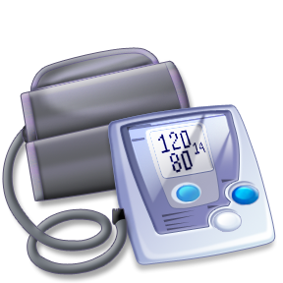Monitoring blood pressure is one way that patients can take care of themselves. Blood Pressure reading provide a good indicator that everything is well, or that you should seek medical advice.

One of DaBKA’s successful projects so far has been providing our local patients with blood pressure monitors.

We have handed out over 230 blood pressure monitors since we started the scheme 5 years ago

If you are a local patient and would like a blood pressure monitor please ask at your local unit, or contact us on 07444 281 141.

**Free Fistula / transplant wristbands**

**for local patients**

We stock silicone wristbands that patients can wear if they wish to do so. These wristbands, hopefully, will help to alert medical staff in the event of an emergency that a patient has a fistula and / or has had a transplant.

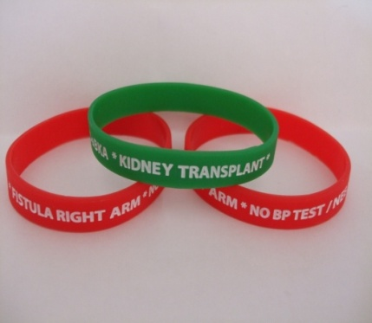

We hope that this may prevent fistula arms being used to measure blood pressuer, take bloods etc. and also prevent innapropriate medication being used. The standard size of the bands is 20cm, please contact us if you require a different size.

The wristbands are free to kidney patients in our local area

(or £1.50 including postage and packaging if purchased).

If you would like a wristband, ask your local unit or give us a call.

**Doncaster and Bassetlaw Kidney Association**

Denise Holliday – Secretary 07444 281 141

Email: admin@dabka.org.uk

Web: www.dabka.org.uk

**Doncaster Royal Infirmary:**

Main Switchboard Number 01302 366666

Renal Outpatients 01302 647043

Ward 32 01302 647038

Haemodialysis Unit 01302 381455

Peritoneal Dialysis Nurses 01302 366666 ext. 4801

Debbie Starbuck 07770 748730

Pre-Dialysis 01302 366666 ext 3879

Claire Mitchell-Haynes 07920 085327

**Bassetlaw Haemodialysis Unit:** 01909 511 150

**Dearne Valley Dialysis Unit:** 01709 599 190

**Sheffield Northern General:**

Renal Assessment Unit 0114 271 5320

RUF Ward 0114 226 6391

*Answer to the add a letter puzzle: performer*

Doncaster & Bassetlaw Kidney Association

Registered Charity number 1123780

6 Medley View

Conisbrough  
Doncaster

DN12 2DT

|  |
| --- |
|  |

|  |
| --- |
|  |