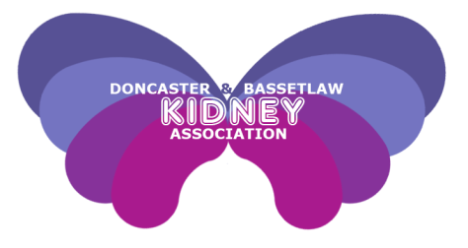

Newsletter

* 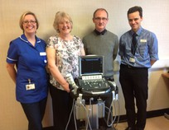

DaBKA send a belated thank you to Brian from Conisbrough for his hard work selling pens in the last few months – sorry we have forgotten to mention you in the last issue.

Doncaster & Bassetlaw Kidney Association

www.dabka.org.uk

Registered Charity Number 1123780

Christmas party 2014 2

Recipe 3

DaBKA’s new committee 4

Quiz 8

Bassetlaw Fun Day 12

A Christmas wish come true 21

Contact details 24

Inside this issue:

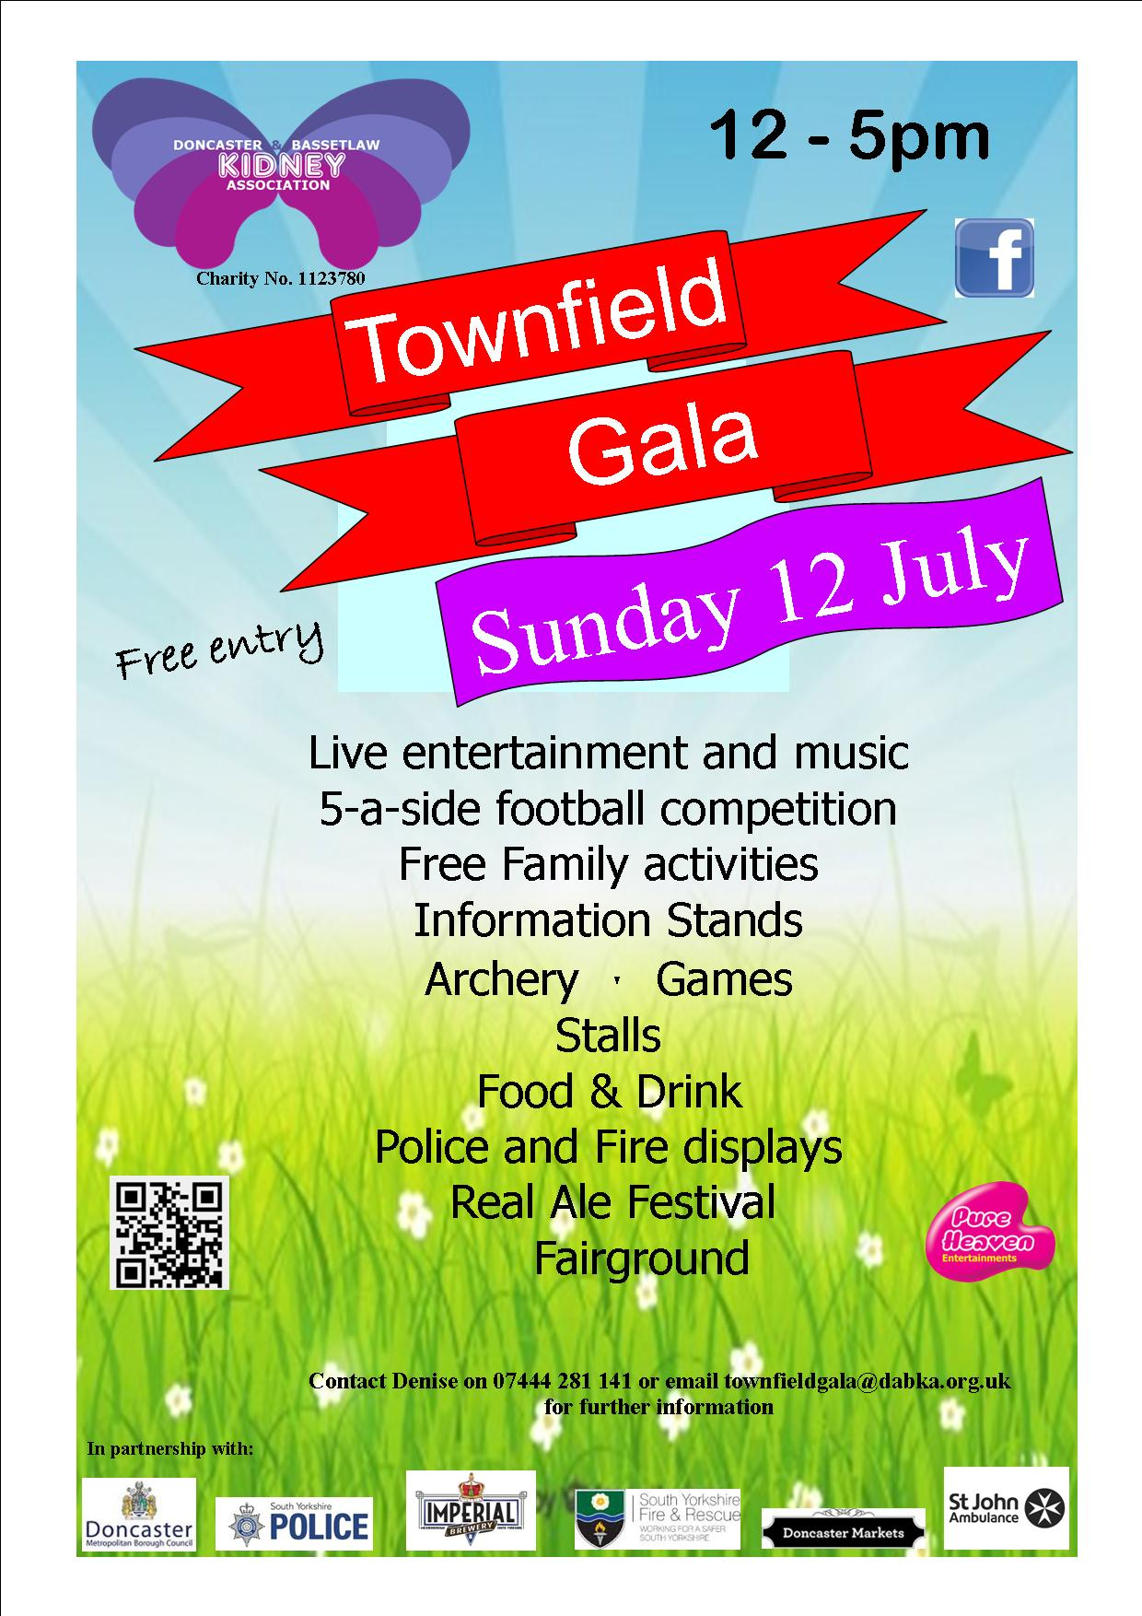

*The official presentation took place on 10th march 2015 at DRI.*

*Pictured left to right: Michelle Johnson – Renal Vascular Access Nurse, Christine Spyve – DaBKA Treasurer, Sean Starbuck – DaBKA Chairman and Dr Ian Stott, Consultant Nephrologist*



Last year, DaBKA launched an appeal to help raise funds to purchase a dedicated mobile ultrasound fistula scanner to enable Michelle Johnson, the renal vascular access nurse, to take her service to patients at the Dearne Valley (Mexborough), Bassetlaw (Worksop) dialysis units and also those patients on home haemodialysis.

DaBKA, with lots of excellent support from volunteers and fundraisers – who donated a very generous £6000 - together with a generous grant from the British Kidney Patient Association, purchased the ultrasound scanner in March.

*Michelle Johnson said “having a dedicated ultrasound scanner at my disposal has made my role more dynamic. This morning I was able to visit Bassetlaw dialysis unit and help a patient with needling issues, and track a fistula which was not functioning well, and check flows in an AV graft 2 weeks post op. I can monitor, diagnose and refer directly to vascular surgeons to make the patients’ journey more efficient. Patients can drop in and see me with any concerns, and the ultrasound is always available for use. Yesterday I was called to the dialysis unit to help cannulate a difficult access, and today I will be measuring arterial flows in clinic with a surgeon to decide if a fistula needs to be ligated or banded. I have a fabulous job, and having the ultrasound machine has enriched my knowledge, and enabled me to provide a more efficient and accessible service for our patients. I can’t thank BKPA and DABKA enough for providing this equipment.”*

A huge thank you from DaBKA to everyone who helped raise funds,

it is really appreciated.

.

**Christmas Party 2014**

A big thanks to everyone who attended our Christmas party last year at the new location of the Keepmoat Stadium, Doncaster.

It was great to see so many of our members and some new faces too.

“It was great to see so many of our members.”

The Christmas raffle drawn on the night was very successful, raising over £600 with some good prizes donated from patients and companies.

The quiz and our new feature of ‘stand up bingo’ also proved popular.

There was ample food provided by the staff at the Keepmoat, including low potassium alternatives, which everyone seemed to enjoy As featured later in the newsletter, we have new committee members this year, and we will be staging social events like this during the coming months.

If you have any suggestions or comments about what we could do, or the type of events you would like, please feel free to get in touch and we will take on board all of your views and ideas.

Once again, thank you for your continued support and we look forward to seeing you all this year.

**By Andy & Mary Wraith**

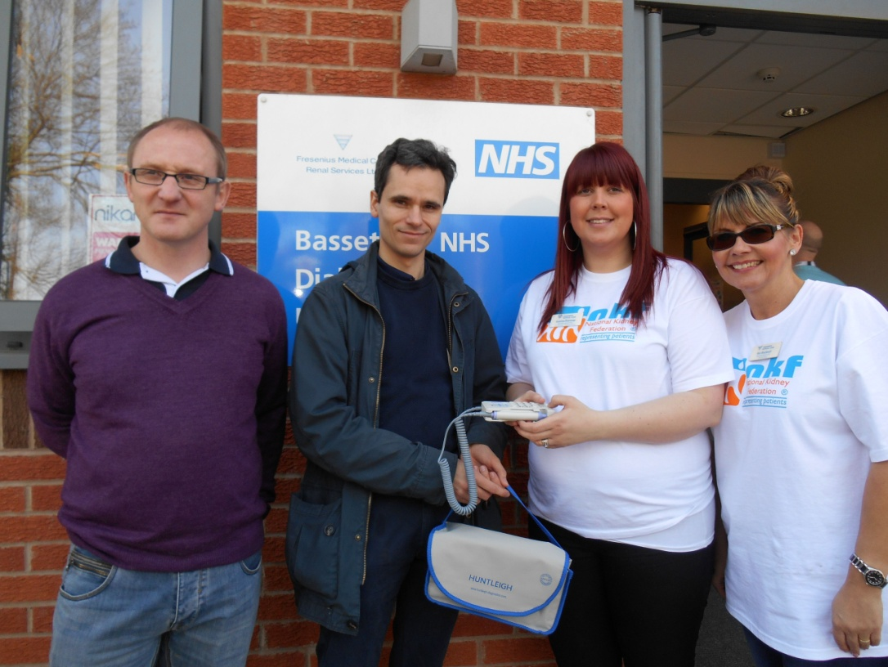

*DaBKA Chairman, Sean Starbuck presenting Dr Ian Stott, Gemma Dewsnap and Bev Blackwell with a Doppler scanner for the Bassetlaw Dialysis Unit.*

**Renal friendly recipe**

Thanks to Alison Zientek, Lead Renal Dietician for sending in this tasty recipe that all the family will love. If you have any queries about your diet, please do not hesitate to contact a member of your renal team.

**Tagliatelle Pasta with Poached Fresh Salmon and Dill Cream**

**Serves 4**

150g (5oz) Tagliatelle pasta 100g (3 ½ oz.) broccoli florets

300g (10oz) fresh salmon Juice of 1 lime

½ lemon 100g (3 ½ oz.) crème fraiche)

150g (5oz) asparagus spears 1 level tbsp. fresh dill, chopped

100g (3 ½ oz.) cucumber, cut into ribbons, to garnish, A pinch of ground black pepper

Bring a large pot of water to the boil. Add the Tagliatelle pasta and cook as per packet instructions, stirring regularly to prevent the pasta sticking. Once cooked, drain and then run cold water over the pasta to cool it and stop it from cooking any further. Set aside.

To poach the salmon, place the salmon in a pot of slightly boiling water, add the half lemon and dill to the water and poach for 7-9 minutes, until the flesh of the fish has turned pale and opaque. Remove the salmon from the pot and leave it to cool.

Blanch the asparagus and broccoli by parboiling in boiling water for 4-6 minutes, then drain and run them under cold water to stop the cooking process.

Place the olive oil in a generous sized pan; add the asparagus spears and broccoli florets and pan- fry slightly. Next add the cooked Tagliatelle and crème fraiche and mix well. Flake the poached salmon into the pasta trying to keep it a little chunky. Then add in the lime juice and chopped dill and mix. Remove the dish from heat, and season with black pepper.

To prepare the cucumber, use a vegetable peeler to peel it lengthways and make nice cucumber ribbons

Serve the pasta in warm bowls with the cucumber ribbons on top.

**Meet DaBKA’s 2015 Committee part 1**

**Sean Starbuck - Chairman**

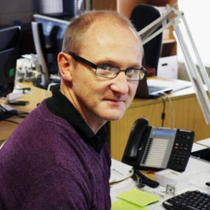Hello to everyone! I would like to introduce myself. My name is Sean Starbuck, I have lived in Doncaster all my life. I am 47 years old, married to Debbie who is a Renal Specialist Nurse at Doncaster Royal Infirmary and I have two grown up daughters.

In my professional life I am a Quality Manager at an engineering / Diecasting company in Rotherham. The company is employee owned and I am a member of the Glide board looking after the welfare and wellbeing of our employees.

Socially I am very active as a volunteer with St John Ambulance where my role is currently Regional Youth Development Officer for the North East of England, working with children aged 5 – 18. I am Chairman of the White Rose Fellowship group which is for retired members of St John Ambulance.

My association with the care and support of Renal patients goes back to 1990 when my wife first joined the Renal Department at the Northern General Hospital in Sheffield. I have been involved in many fundraising events over the years and have supported DaBKA since 2007.

I feel proud and privileged to be given the opportunity to be the Chairman of DaBKA. Our new committee is working extremely hard to develop the charity with clear aims to support Renal patients and their families with our new rebranding exercise to be launched in July.

If you would like to help or support the charity in any way, or if you personally require any help or information please do not hesitate to contact me. I hope to meet you all soon at one of our upcoming events.

**Chris Holliday – Vice Chair**

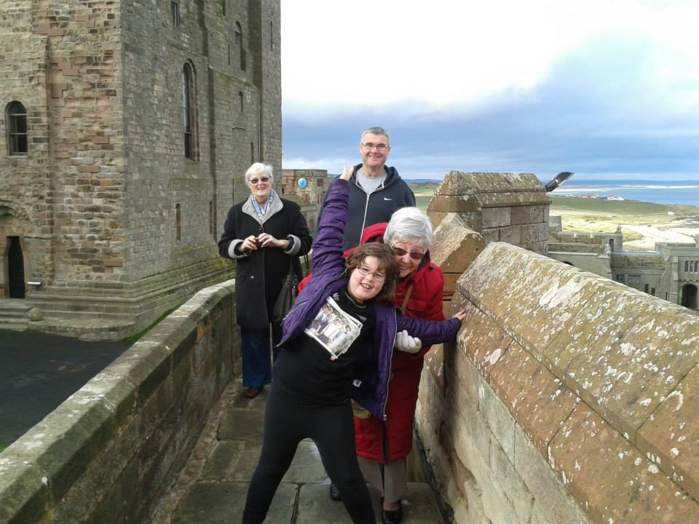Hi I’m Chris. I’ve been a proud supporter of DaBKA since its formation in 2007, and have helped DaBKA with various fundraising events, Christmas parties and coach trips. Denise and I have been married for 15 years. Although I am not a renal patient myself, as the partner of a renal patient I have seen the other side of renal life so to speak – from Pre-dialysis, PD, Haemodialysis and transplant. I feel that I can offer support and advice from our extensive experiences to help other people in the same position as we are. The thing I’ve learnt most is that although life is difficult and stressful at times, friendly helpful advice and positive attitudes really do make a difference. I am happy to share my experiences if it helps others and I’m honored to step up and be a part of DaBKA’s new enthusiastic team. With your help no matter how small we can only improve our service to patients and their families. I look forward to welcoming you at one of our upcoming meetings, events or socials.**Meet DaBKA’s 2015 Committee Part 1 ctd…**

**Christine Spyve – Treasurer**

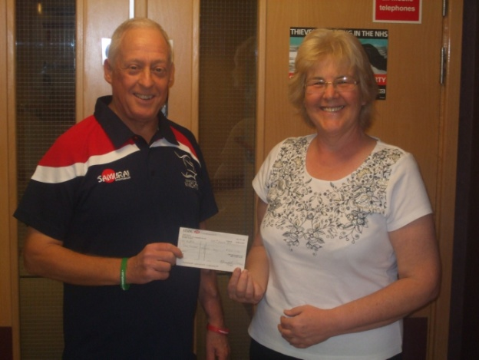My husband developed renal problems in the late 1980’s and went on Peritoneal Dialysis in 1990. He remained on PD for 4½ years and then changed to haemodialysis in 1995. In 1999 we became the first husband/wife transplant at Sheffield Northern General. Although the transplant itself worked well Neil developed gastric problems and then septicemia and sadly passed away in 2000.

In 2003 our daughter Katherine became ill following the birth of twins it was discovered she had renal failure and needed dialysis immediately. It was a complete shock as there had been no indication that Neil’s problem was a genetic one.

A couple of years later our other daughter Kerry underwent a biopsy which diagnosed the rare genetic problem of Medullary Cystic Kidney Disease. Kerry needed to go on dialysis early 2006 followed a year or so later by our son Richard as they had all inherited MCKD. Unfortunately Katherine also developed heart and lung problems and tragically passed away suddenly in February 2010 aged 32.

On a more positive note, our son Richard had a successful transplant early 2010 which has enabled him to return to full time employment and lead a relatively normal life with his young family, and our daughter Kerry had a transplant on Christmas Eve (her story is later in the newsletter)

I attend Doncaster Renal Unit for annual check-ups to make sure my remaining kidney is still working ok. I became Treasurer of the newly formed DaBKA in 2008.

**Andy Wraith – Fundraising Manager**

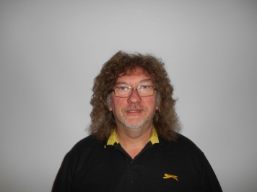I’m Andy, as Mary’s husband of 25 years, it was a big surprise to find the serious nature of her illness, however, with lots of help from the renal nurses and staff I was able to take an active role in her daily care, which, as you all know, is a complicated business. So we now look forward to helping others by being part of DaBKA as fundraising manager and assisting with events and fundraising.

**Meet DaBKA’s 2015 Committee Part 1 ctd…..**

**Denise Holliday – Secretary**

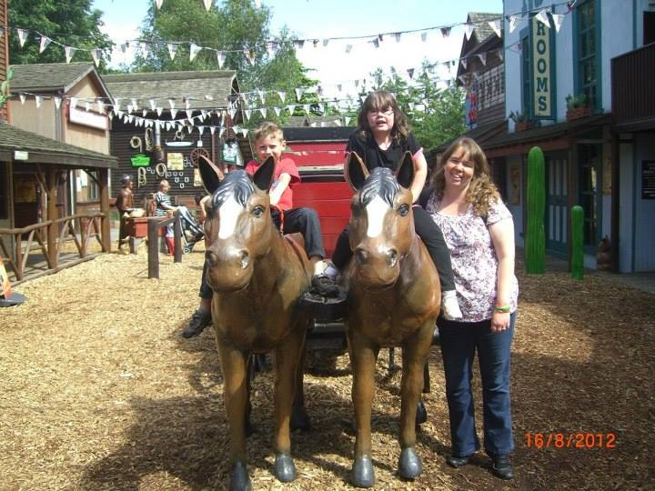I was first diagnosed with renal failure during my pregnancy in 2005, it was an enormous shock as I had had no previous indications or symptoms.

Our daughter Georgina was born safely at 32 weeks, she was very poorly but was a little fighter, coming out of neonatal intensive care within two weeks.

In September 2007, I went on the transplant list. This was a daunting time with many mixed emotions. I started Peritoneal Dialysis at home in 2008, four times a day then moving to overnight, (not an easy task with a toddler!) – but with full support from the superb renal team at Doncaster, family, friends and my husband Chris, they helped to make life run as smoothly as possible.

After a severe bout of peritonitis and had to change to Haemodialysis at Doncaster. When the unit at Mexborough opened I transferred there as it was closer to home.

My call for transplant came on 26 January 2011. My kidney was ‘asleep’ for 21 days but when he woke up (I named him Colin) it was an amazing feeling. Although the transplant process has not been easy and continues to be an emotional roller coaster at times, I am so grateful for the chance of being an active Mum for Georgina.

All of the renal staff who have looked after me and continue to do so, have been excellent and I will never be able to thank them enough for the care and support they have given me and my family.

I have a good insight into how renal problems affect patients and their families which enables me to help other patients. I have been secretary of DaBKA since 2007 and have met some really inspirational people.

**Malcolm Fielding – Membership Secretary**

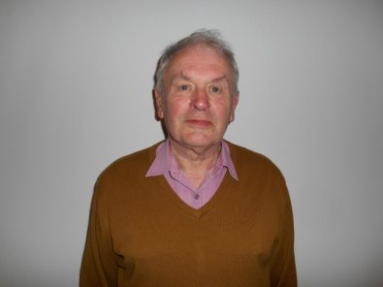I became involved with the Kidney Association at its inception and joined the committee then. I volunteered to become the Membership Secretary about six years ago. Although I do not suffer from any type of renal failure I do suffer from kidney stones and a slight liver disorder.

**Meet DaBKA’s 2015 Committee Part 1 ctd…**

**Malcolm Fielding – Membership Secretary continued**

I am married and live in Arksey, Doncaster. I have two grown up children and one grandson who is six years old going on sixteen

My main interests are the Inland Waterways of Great Britain. I do not have a boat but am involved heavily with a Canal Project I started up in 1988 while working for Sheffield Council Social Services Department looking after people with learning disabilities.

I was Chairman of the South Yorkshire and the South Yorkshire Dukeries Branch of the Inland Waterways Association until 2001 and am now their Branch Secretary and also edit the branch magazine “Keels and Cuckoos”. The title represents the boats that used to trade on the Sheffield and South Yorkshire Navigation and the Chesterfield Canal.

**Mary Wraith – Committee Member**

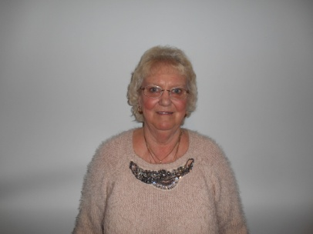I have been a renal patient since 2004 when I was diagnosed with acute kidney failure which came as a complete shock to me. Luckily, I was found to be suitable for peritoneal dialysis at home which was a totally new way of life for me. But after being placed on the transplant list and one failed transplant in 2009, one of my daughters was found to be a match and I had a live transplant in 2010.

To date, we are both well and I can live a normal life again, so we are please to help DaBKA in any way I can, as we know what renal patients go through each day.

*Meet some more Committee members and volunteers in the next issue.*

**Don’t forget we will all be at the Townfield Gala on Sunday 12 July (more info on page 17)**

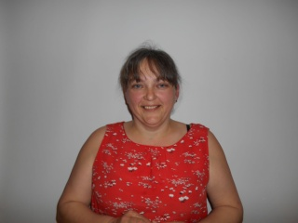 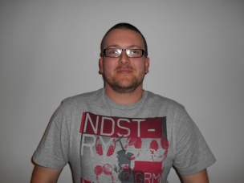 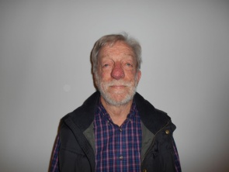 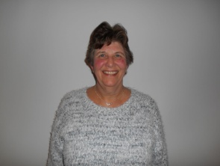

**Free blood pressure monitor for local patients**

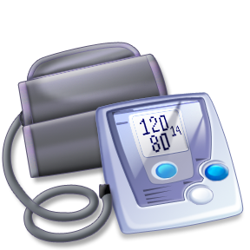Monitoring blood pressure is one way that patients can take care of themselves. Blood Pressure reading provide a good indicator that everything is well, or that you should seek medical advice.

One of DaBKA’s successful projects so far has been providing our local patients with blood pressure monitors.

We have handed out over 230 blood pressure monitors since we started the scheme 5 years ago

If you are a local patient and would like a blood pressure monitor please ask at your local unit, or contact us on 07444 281 141.

**Free Fistula / transplant wristbands**

**for local patients**

We stock silicone wristbands that patients can wear if they wish to do so. These wristbands, hopefully, will help to alert medical staff in the event of an emergency that a patient has a fistula and / or has had a transplant.

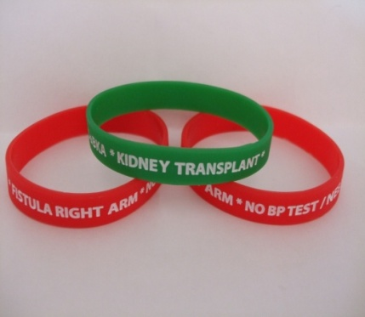

We hope that this may prevent fistula arms being used to measure blood pressuer, take bloods etc. and also prevent innapropriate medication being used. The standard size of the bands is 20cm, please contact us if you require a different size.

The wristbands are free to kidney patients in our local area

(or £1.50 including postage and packaging if purchased).

If you would like a wristband, ask your local unit or give us a call.

**Know Your Doncaster Quiz Part 2**

Below are clues to villages and towns in the Doncaster area, If you are unsure of them reference to a road map will help with identification. The answers can be found on the last page.

*Good Luck!!*

1. Cap pasture

2. A rolling stone doesn’t gather any

3. Sounds like a twisted meadow

4. An automobile’s highland small holding

5. Timber comes down to earth

6. Pig meat on a stick

7. The town of the Duchess of Windsor

8. Everyone under canvas

9. In the singular, Oliver Twist characters home

10. Lofty leas

11. Noah’s vessel sounds like it ended in the ocean

12. You need a candle-lighter after this marshy land

13. Footwear for a Scottish church **Malcolm Fielding**

**Pride of Hall Cross Award**

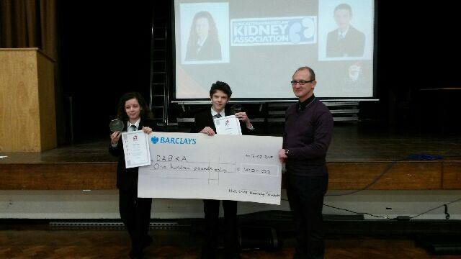

Pictured above are Kirsty and Kieren who presented DaBKA Chairman, Sean Starbuck with a cheque for £100. They had won the ‘Pride of Hall Cross’ school award for their splendid help with DaBKA during the past few years. Congratulations and thank you to both Kirsty and Kieran for all your hard work.

**British Kidney Patient Association Grants**

The BKPA provide grants for kidney patients

They can help with the cost of domestic bills such as car insurance and tax, heating costs, telephone installations, and TV licenses. They may also help with the purchase of domestic goods like washing machines and carpets.

They also give grants to families and individuals towards the cost of a basic holiday in the UK or overseas. The grant can be used to cover the total cost if modest, or or it can be used as a contribution to the final cost of the holiday.

Grants are also available for education and training and also some travel costs.

There are conditions and limitations attached to the grants and application forms will need to be signed by your medical team.

A full list of grants offered can be found at [www.britishkidney-pa.co.uk,or](http://www.britishkidney-pa.co.uk,or) by calling 01420 472 021.

**British Kidney Patient Association -**

**Support Phone Line**

The British Kidney Patient Association have set up a support phone line service.

For units like ours without counselling services, this gives kidney patients a chance to talk to an experienced counsellor during challenging times.

Jacquie Fraser is available via phone and email from the BKPA offices every Tuesday and she will listen and provide appropriate support.

In her capacity as a support worker, she’ll also be able to guide patients with personal grant appalication to the BKPA where there is no social worker on site.

Contact Jackie on 01420 541 424 or

via email at [jacquie.fraser@britshkidney-pa.co.uk](mailto:jacquie.fraser@britshkidney-pa.co.uk)

*If you are having difficulties, please remember, you can always speak to a member of your renal team or your family GP.*

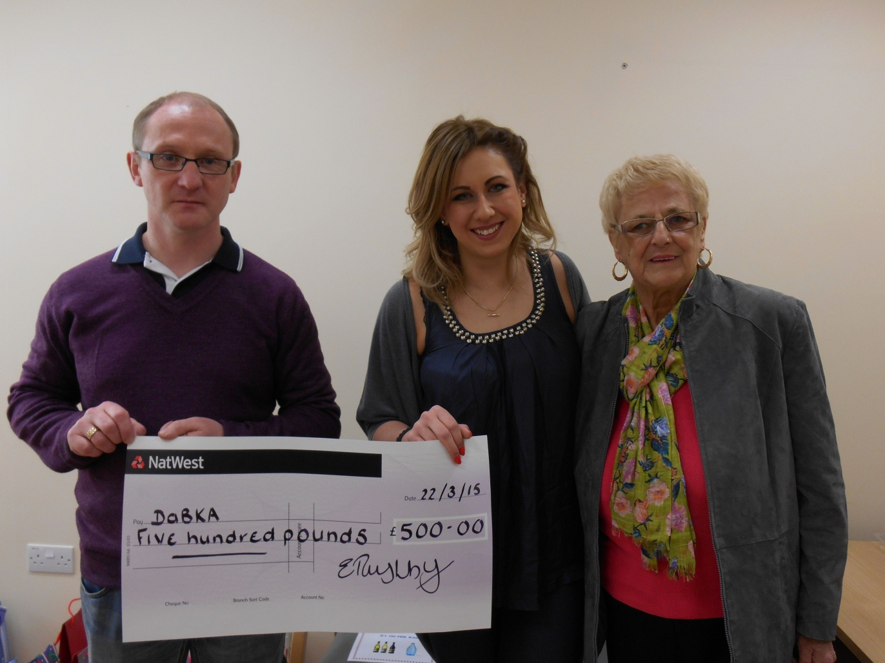**Presentation to DaBKA**

*Pictured above: DaBKA chairman Sean Starbuck receiving a cheque for £500 from Ellenor Rushby and Madeline Bownes at the Bassetlaw Dialysis Unit, Worksop*

On Sunday 8th March 2015, Ellenor Rushby took part and completed the Retford Half Marathon.  Ellenor's grandma, Madeline Bownes is a patient at Bassetlaw Dialysis Unit in Worksop, and Ellenor wanted to raise the money to help local Kidney patients.

You can view Ellenor's Justgiving webpage at www.justgiving/dabka and you are still able to donate if you wish to do so.

**A huge thank you to Ellenor and all her supporters from DaBKA for raising the magnificent £500 and very well done for completing the half marathon.**

**Peritoneal Dialysis Easter Event**

**By Lisa Perham – Renal Dietician**

**DaBKA new contact Details**

Please note our new contact details:

Telephone 07444 281 141

Email: [admin@dabka.org.uk](mailto:admin@dabka.org.uk)

[www.dabka.org.uk](http://www.dabka.org.uk)

Facebook: dabka/2015

Twitter: dabka2015

**Date for your diary**

The DaBKA **Annual General Meeting** will be held on Sunday 27 September followed by a FUN SOCIAL gathering, more info to follow soon!

The peritoneal dialysis (PD) team at Doncaster Royal Infirmary held an Easter event in Renal Outpatients on Monday 30th March for PD patients and their families.

Renal friendly recipes were put together by the renal dieticians and made by the catering department at DRI.

The topic for the event was constipation and the importance of preventing it through the right diet and medication. Approximately 80% of our recent PD patient issues have been related to constipation and faecal impaction, and this has had a massive impact on patient treatment. This in turn can have huge physical and emotional repercussions, with unnecessary trips to the hospital and problematic dialysis.

The hope is that by talking about constipation, and making the topic a little less taboo and a little bit fun, patients will feel more comfortable talking to us about their bowel habits

The event was a good opportunity for PD patients to meet each other and discuss experiences. Thank you to Doncaster and Bassetlaw Kidney Association (DaBKA) who sponsored the food provided at the event.

**Bassetlaw Dialysis Unit Family Fun Day**

**By Gemma Dewsnap, Clinic Manager, Bassetlaw Dialysis Unit**

Last year as part of World Kidney Day, we held a raffle, a homemade cake stall and some various other activities in order to raise some money for the National Kidney Federation. As the event had a fantastic outcome and we raised over £1100, we decided that this year we would hold a family fun day here at the Bassetlaw Unit in order to enable patients, staff, family and friends to come and spend the day with us in the hope of raising funds and having an enjoyable day.

With this in mind we set up a raffle, tombola, a coffee and cake cafe, a wine and water stall, guess the name of the bear and doll, guess how many sweets are in the jar, nail painting, face painting, bouncy castle and a homemade cake stall.

 We also asked external stall holders to attend the event to which we also had a handbag stall, 2 Jewellery stalls, the NKF, DABKA and the bodyshop here.

As we knew children would be attending the event we also contacted the local emergency services who provided a fire engine and police car for children to sit in and play as well as a Jacket Potato van.

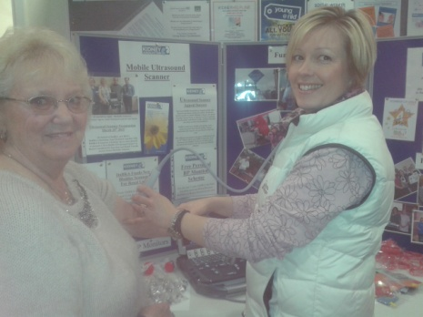The portable ultrasound scanner that DaBKA had recently presented was on show (information on page 1)

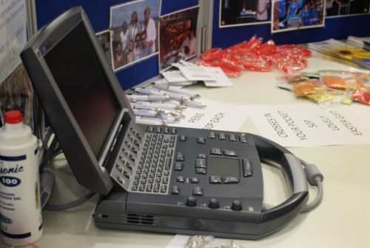

The day itself was a huge success and we had a fantastic amount of visitors who attended the unit and the atmosphere was amazing.  In total we raised over £2500, and are still to receive a donation from Barclay's of a further £985 as one of their staff members was here running the raffle and as a company they double any fundraising their employees participate in.

The day its-self would not have been possible without the generosity of our patients and staff, people who donated items to help the event and also for giving up their time on the day to support a fantastic cause.   
Fresenius Medical Care will also be doubling any amounts raised on the day.  **Bassetlaw Dialysis Unit Family Fun Day**

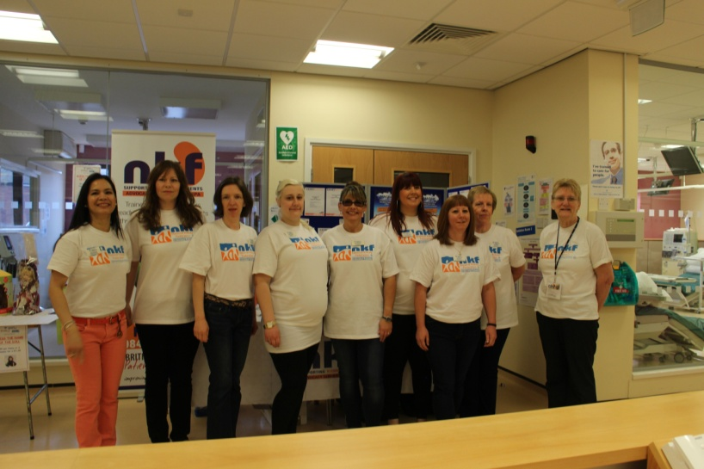

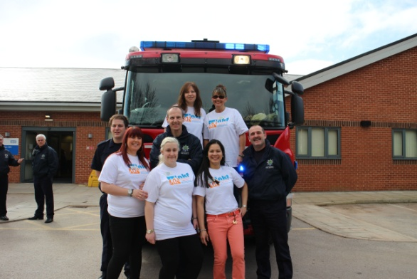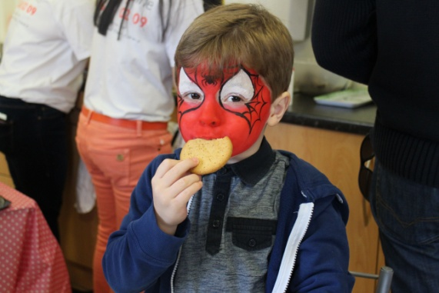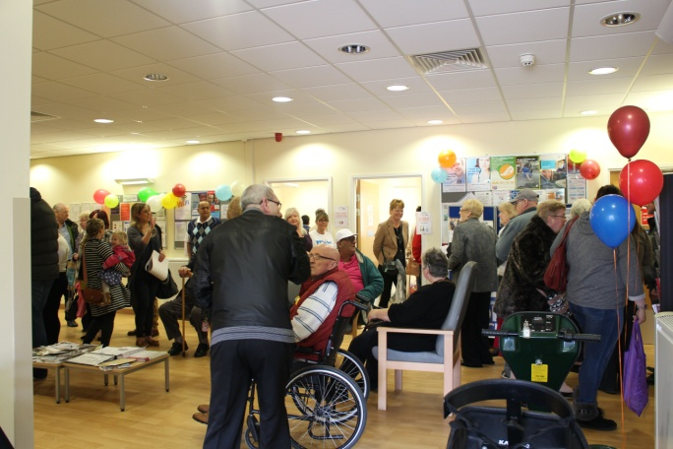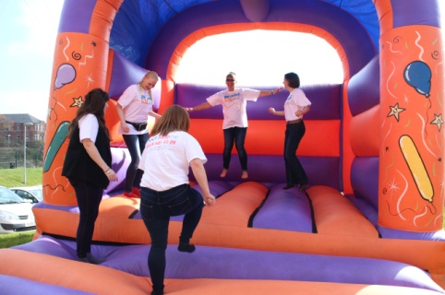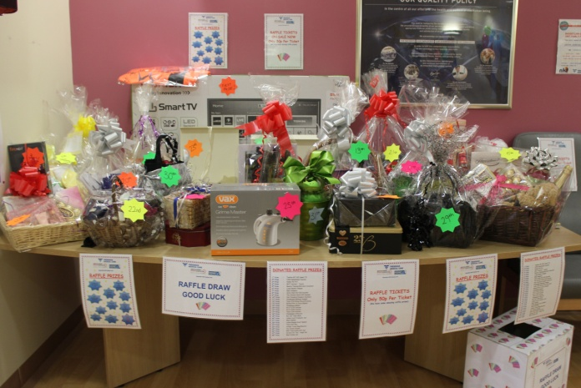

**Dialysis Games at York – Sunday 13th September 2015**

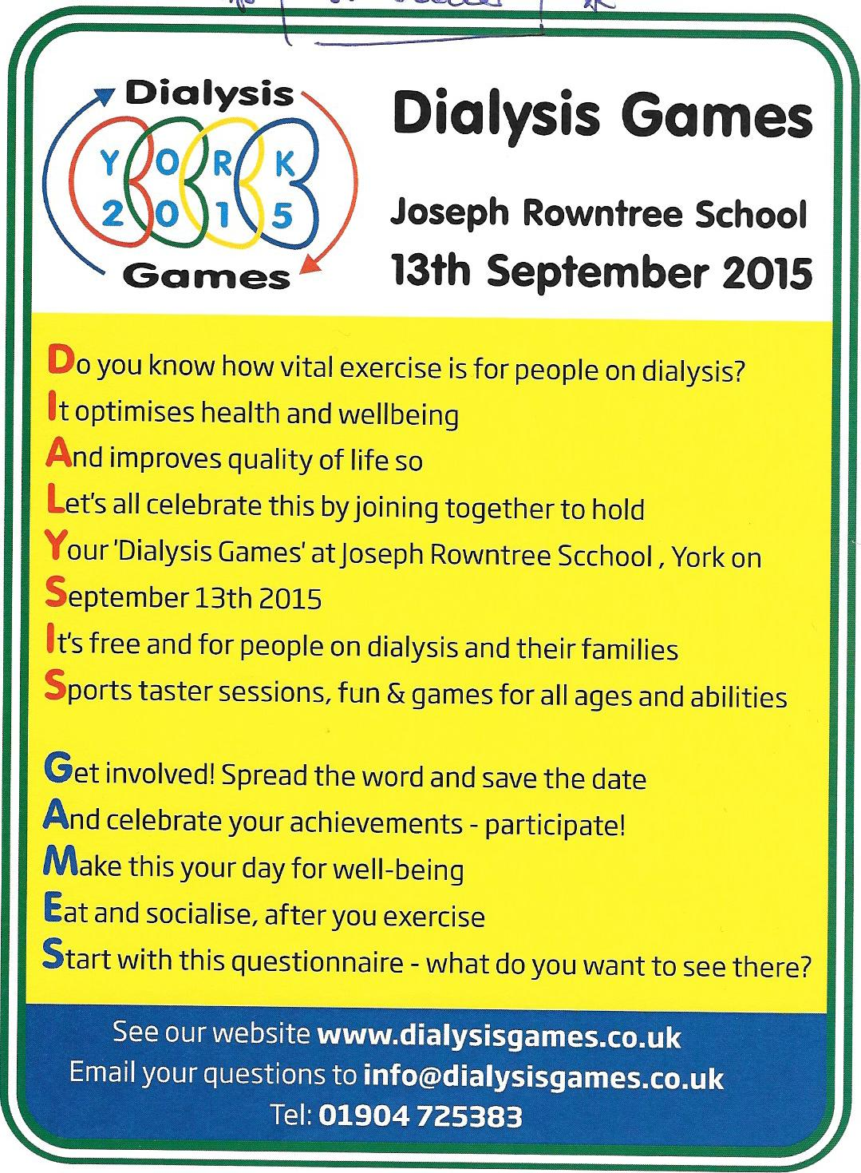

**Are you a dialysis patient and interested in attending the dialysis games?**

– if so, please give us a call or text on 07444 281 141, or email [admin@dabka.org.uk](mailto:admin@dabka.org.uk)

**Dialysis Patient participants will get free travel.** Other seats are £10 each.

The coach is also dropping off in York centre, so if you would like a day out, please contact us ASAP. Places are first come, first served.



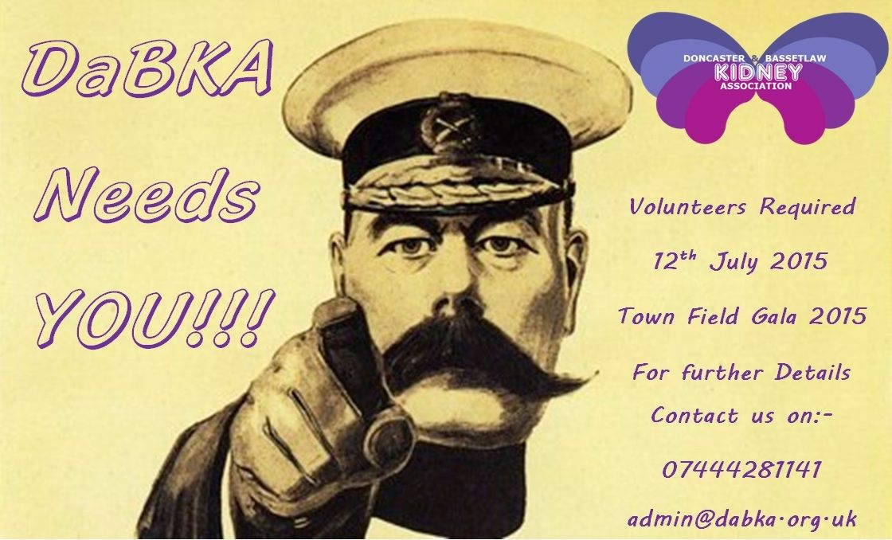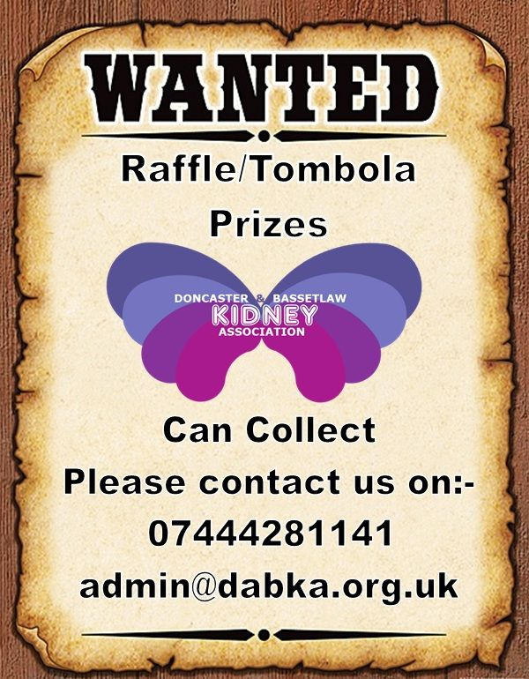**Townfield Gala on Sunday 12th July, 12 noon to 5pm**, is an exciting fun-filled community afternoon for all the family. Admission is free.

If you would like to help out on the day by

* manning the tombola stall with other volunteers,
* marshalling the mascot race,
* Helping out in any way however small, please contact us on 07444 281 141 or email admin@dabka.org.uk

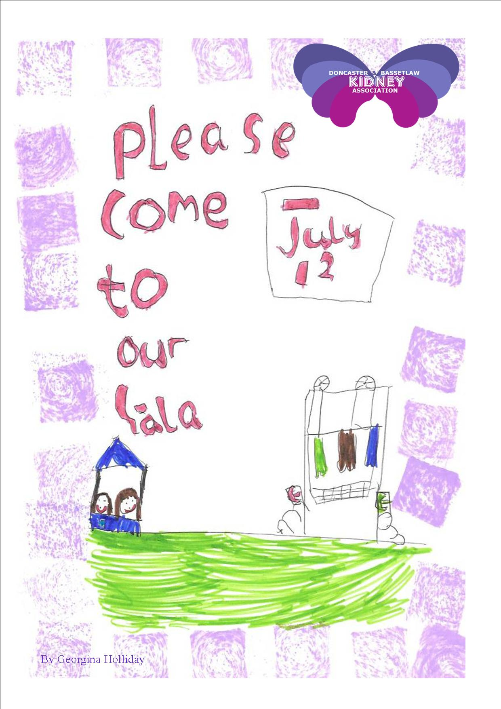

Come and celebrate the talents of your local community by watching live music and dancing all afternoon, hosted by Pure Heaven Entertainments.

South Yorkshire Fire and Rescue are coming along with a fire engine and doing chip-pan fire demonstrations. There is a Display Ambulance and an ambulance from the National Emergency Service Museum.

Yorkshire Ambulance Service and Tom Thorpe Martial Arts among others will be taking part in demonstrations of their work.

Try your hand at free Den Building, take part in an archery lesson or support a team in the 5-a-side football competition!

Dare you view a tarantula or snake in the nature safari? We have a mini Real Ale festival by the Imperial Tap & Brewery from Mexborough, a funfair and food and drink stalls.

With lots of activities to do and watch, stalls and information stands to look at, why not bring along your family and enjoy this superb afternoon of family fun!

***Please come and meet the new DaBKA team,***

***it will be great to see you there!***

Summer raffle 2015

There are some fantastic prizes in the summer raffle. Thanks to all who have donated prizes.

Tickets are now on sale in your local renal unit, £1 each. The draw will take place at the Townfield Gala on Sunday 12th July. If you would like to sell some raffle tickets, please call us on 07444 281 141 or email [admin@dabka.org.uk](mailto:admin@dabka.org.uk) Prizes are:

1st 32” Blaupunkt Freeview HD TV.

2nd Kindle Fire HD.

3rd Doncaster Rovers Family Ticket.

4th George Foreman Family Grill.

5th 43 Piece Stanley Fairmax Tool Set.

6th 1 Pair Vulcan Hangar Tour Tickets.

7th Younique Mascara & Eyeliner Set.

8th Britool ¼ in Drive Bit 30 pce set.

9th South Yorkshire Aircraft Museum Family Pass.

10th Stanley 39 Piece Socket & Bit Set.

11th South Yorkshire Aircraft Museum Family Pass

12th Swim & Skate Pass 4 People At Doncaster Dome

13th 1 Pair Tickets Vue Cinema.

14th Britool Ratcheting Screwdriver.

15th 1 Pair of tickets for Doncaster Superbowl

16th  Purple Voucher Book.

17th 1 Pair of tickets for Doncaster Superbowl

18th Soft Toy & Bottle of Wine.

19th Liverpool FC axxis Training Shirt.

20th Stanley Tool Belt.

Infra Red Scanner Appeal 2015

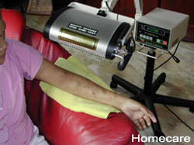

**This year, DaBKA are launching an appeal to purchase a Far Infrared Therapy Unit. The cost of the unit is £4,500.**

Doncaster Royal Infirmary Renal Unit has had a Far Infrared Therapy Unit on trial for 3 months. Patients have reported reduced pain in their fistulas during dialysis and that is very popular.

The benefits of the Far Infrared Therapy Unit to patients are:

* It can help relieve pain in fistula arms
* It helps improve access blood flow that enhance dialysis efficiency
* With long term use can improve the survival of vascular access (AV Fistula or AV Graft)
* Reduced vascular access complication related to surgery
* It is user friendly and safe
* Helps improve the quality of dialysis sessions

|  |
| --- |
|  |

**A Christmas Wish come true!**

**By Kerry Spyve**

My name is Kerry Spyve and I had a great Christmas last year as on Christmas Eve I had the call for a kidney transplant.

I had been waiting 8 years.

I know they tell you to expect a call anytime but when it really comes through it still comes as a shock. It all started in the very early hours of Christmas Eve about half an hour into it luckily we were still up. The hospital stated a kidney had been donated and I should go to Sheffield Northern General Hospital in case it was a match, I had to pack a bag and get to Sheffield as soon as I could but there was still a way to go before I could celebrate.

I dialysed and my bloods were taken as I waited for news. Eventually after waiting all day I was told it was all going ahead and that’s when my panic started, my mum was on her way and I thought I would miss her. I was taken to the operating theatre for my life changing operation.

During the afternoon of Christmas Day I had the tube taken out of my throat and I celebrated Christmas by having a mince pie. Later when my mum visited me I realised the kidney had started working straight away. From then everything things went from strength to strength. I was transferred to a renal ward.

I was surprised how well I was feeling even after major surgery I felt like I could take on the world but my body soon told me different. I took a selfie a few days after the operation and sent it to my partner, he text back saying how much healthier I looked.

I stayed in hospital for one week, and on New Year’s Eve I saw the New Year in with my mum and a mug of warm milk.

I am now going to hospital every couple of weeks to check that everything is still going very well and am looking forward to getting back to work and living my life to the full.

*DaBKA sends Kerry our very best wishes x*

**Fundraising for November 2014 to April 2015**

**By Christine Spyve**

**Christmas Card Sales – Total £1,363.00**

DRI £637

DVDU £270

Bassetlaw £153

S Talbot £ 69

M Smedley £ 81

Others £153

**Christmas Raffle** £629

**Kickathon from children at Direct Martial Arts**- £170.28

**J & D Knott** £155

**Party Contributions** £140

**Mrs Waddington** £100

**Wristband Sales** £188

**DVDU Raffle** £281

**Collection Boxes:**

A Abdulla in his computer shop in Rossington £53

John Bull Pub at Thorne £46.24

Victoria Inn at Thorne £55.40

**Ultrasound Scanner Donations**

Anon £1,000

B Garne £25

R Taylor £50

**Fundraising for November 2014 to April 2015**

Sadly, some donations are from those who have lost loved ones and are sent in lieu of flowers and in memory of someone special.

**In Memory:**

Mary Chamberlain £150

Freda Marshall £150

Mrs D Chambers £334

We would like to send all family and friends our condolences and thank them for thinking of others at such a sad time.

**Sale of Pens and Keyrings**

Bassetlaw Unit £32

Bassetlaw Gala Day £27

A & M Wraith £50

**Book sales at DRI** £28

**F & H Withers** £100

**Sponsored Events**

Miss EJ Rushby (Grandmother dialyses at Bassetlaw Unit) completed the Retford half marathon and raised a total of £519 including giftaid.

***Thanks go to everyone who has worked so hard in helping to raise funds for DaBKA, it is very much appreciated.***

**Doncaster and Bassetlaw Kidney Association**

Denise Holliday – Secretary 07444 281 141

Email: admin@dabka.org.uk

Web: www.dabka.org.uk

**Doncaster Royal Infirmary:**

Main Switchboard Number 01302 366666

Renal Outpatients 01302 647043

Ward 32 01302 647038

Haemodialysis Unit 01302 381455

Peritoneal Dialysis Nurses 01302 366666 ext. 4801

Debbie Starbuck 07770 748730

Pre-Dialysis 01302 366666 ext 3879

Claire Mitchell-Haynes 07920 085327

**Bassetlaw Haemodialysis Unit:** 01909 511 150

**Dearne Valley Dialysis Unit:** 01709 599 190

**Sheffield Northern General:**

Renal Assessment Unit 0114 271 5320

RUF Ward 0114 226 6391

***Quiz Answers****: 1.Hatfield, 2. Moss, 3.Bentley, 4.Carcroft, 5. Woodlands, 6. Hampole,*

*7. Burghwallis, 8 Campsall, 9.Sykehouse 10. Highfields, 11.Arksey, 12. Fenwick,13. Kirk Sandall*.

Doncaster & Bassetlaw Kidney Association

Registered Charity number 1123780

6 Medley View

Conisbrough  
Doncaster

DN12 2DT