Newsletter
Annual General Meeting
Doncaster and Bassetlaw Kidney Association
will be holding their Annual General Meeting on:
Sunday 27th September at 2pm
At the Camponile Hotel, Doncaster Leisure Park, Bawtry Road, Doncaster DN4 7PD

Everyone is welcome – places must however be booked (see below)
Please come along and let us know how DaBKA can help you and your fellow patients. We would also welcome new members to come forward and join the DaBKA team. Volunteering for a couple of hours a month would be a fantastic contribution.
We would really like to hear your ideas and suggestions – maybe it is a regular social event, group outings, equipment or just simply some informal sessions about living with kidney problems.
The new committee for the next 12 months will be proposed and voted for.
Small amendments to the charity commission constitution will be voted on, you will then have the opportunity to chat with other members, patients and volunteers of DaBKA.
Light refreshments are available. If you would like to come along, please give us a call or text on 07444 281 141 or email admin@dabka.org.uk

Important information for DaBKA members: Enclosed with this newsletter is a newsletter from the Yorkshire Kidney Research Foundation. They asked us to pass their newsletter onto our members. Please be assured that the YKRF have not been given your personal details and DaBKA will never disclose your information to a third party, without your written consent.

Michelle Johnson said “having a dedicated ultrasound scanner at my disposal has made my role more dynamic. This morning I was able to visit Bassetlaw dialysis unit and help a patient with needling issues, and track a fistula which was not functioning well, and check flows in an AV graft 2 weeks post op. I can monitor, diagnose and refer directly to vascular surgeons to make the patients’ journey more efficient. Patients can drop in and see me with any concerns, and the ultrasound is always available for use. Yesterday I was called to the dialysis unit to help cannulate a difficult access, and today I will be measuring arterial flows in clinic with a surgeon to decide if a fistula needs to be ligated or banded. I have a fabulous job, and having the ultrasound machine has enriched my knowledge, and enabled me to provide a more efficient and accessible service for our patients. I can’t thank BKPA and DABKA enough for providing this equipment.”

A huge thank you from DaBKA to everyone who helped raise funds,
it is really appreciated.

.
Dates for your diary

DaBKA are hosting a Winter wonderland auction & Dinner Saturday 21st November please see page 3

DaBKA’s Christmas Party will be held on Sunday 6th December at the Keepmoat Stadium, Doncaster, more information to follow in the next newsletter

DaBKA Christmas cards are now on sale in Doncaster Royal Infirmary Renal Unit, Dearne Valley and Bassetlaw Dialysis Units
Doncaster & Bassetlaw Kidney Association

www.dabka.org.uk
Registered Charity Number 1123780
AGM 2
Auction Night 3
DaBKA’s new committee 4
Townfield Gala Review 8
Contact details 24
Inside this issue:

Annual General Meeting
At the AGM on Sunday 27th September, the following persons will be standing for election to sit on the Committee and become trustees for the following 12 months

Sean Starbuck Chair
Chris Holliday Vice Chair
Christine Spyve Treasurer
Denise Holliday Secretary
Malcolm Fielding Membership Secretary
Andy Wraith Fundraising Manager
David Alderson Committee
Yvonne Keys Committee
Emma Ross Committee
Phil Smith Committee
Debbie Starbuck Committee
Mary Wraith Committee
If you wish to nominate yourself for any of the above positions or would like to join the committee, please inform DaBKA in writing via email at admin@dabka.org.uk or by mail to: Denise Holliday, Secretary, 6 Medley View, Conisbrough, Doncaster, DN12 2DT no later than 23rd September
If you have any queries, please do not hesitate to give us a call on 07444 281 141

Auction Night – Saturday 21st November 2015

Do you fancy a great night out with your friends? Begin the festive season in style! DaBKA proudly presents A Winter Wonderland Charity Auction Night, sponsored by Pacy & Wheatley

You will:
- Indulge in a 3 course meal
- Experience an evening of great company with special guests Gavin & Jamie McDonnell taking part in a 30 minute Q & A session
- Have the opportunity to bid on some fantastic auction lots
- DJ & Disco
- Bar open till 1am

Formal Wear
£35 per head, £320 per table of ten

Come and join us for a great night!
Sponsorship packages are available. If you know of any companies who may be interested in obtaining details of a sponsorship package or donating an auction lot, please get in touch.

For further information or to purchase tickets, please contact Phil Smith on 0750 600 5199 or email philsmith@dabka.org.uk
Townfield Gala
Once again, the weather was very kind to DaBKA on Sunday 12th July for the Townfield Gala.
After a very heavy rain shower at 8am, the weather brightened up and the sun shone all day.
The Gala was well attended with around 3500 visitors over the event, and it was brilliant to see the local community out in force enjoying the atmosphere of the gala.
Over 80 stallholders and food vendors attended along with a fairground, bouncy castles, extensive emergency services displays, and army exhibitions to name but a few.
A full afternoon of live entertainment – singers, dancers, martial arts, was enjoyed along with fun and games for everyone to participate in.
6 teams competed in a 5-a-side football competition with the winning team, real Sosobad beating Whitehart FC 4-1 in the final, receiving a day paintballing kindly donated by Bawtry paintball.
Radio Sheffield featured us on their Sunday Morning radio show and came along as part of their ‘clueless’ programme. The presenter had successfully to follow a series of clues that were solved by the listener and ended up at the Gala.
12 mascots entered the Doncaster Mascot Race 2015. Congratulations to the winner, Billy the Bag from the Community First Responders.
DaBKA held a very popular tombola, selling out in just two hours and we held a raffle – please find the results on page 7

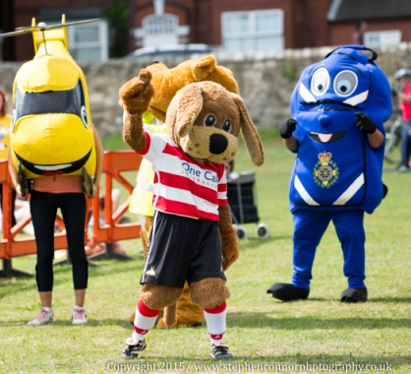
The total amount raised was a fantastic £2445. Thank you to everyone who purchased a raffle ticket or came along and supported us on the day. It was great to see so many of the renal community come along, many local but also a group of renal patients from the Grimsby area. We also had the support of Linda Pickering from the NKF who came along with an information stall.

Thank you from the DaBKA team to all of our volunteers (sorry there are too many to name personally) who worked so hard to make the day a success, from planning the event, organising the 5-a-side football competition, raffle, tombola, mascot race through to the volunteers on the day and those who manned the DaBKA stalls helped make the day run smoothly. Thanks also to the St John Ambulance, DMBC, South Yorkshire Police Fire & Rescue, South Yorkshire Police and Andrew Lambert for co-coordinating the excellent Emergency Service displays section.

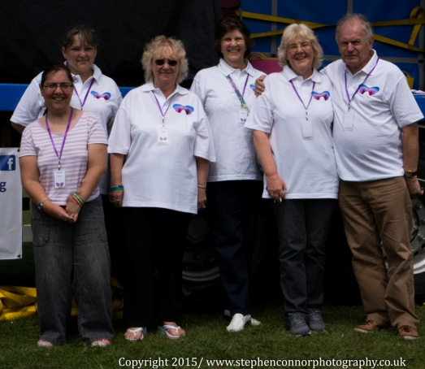
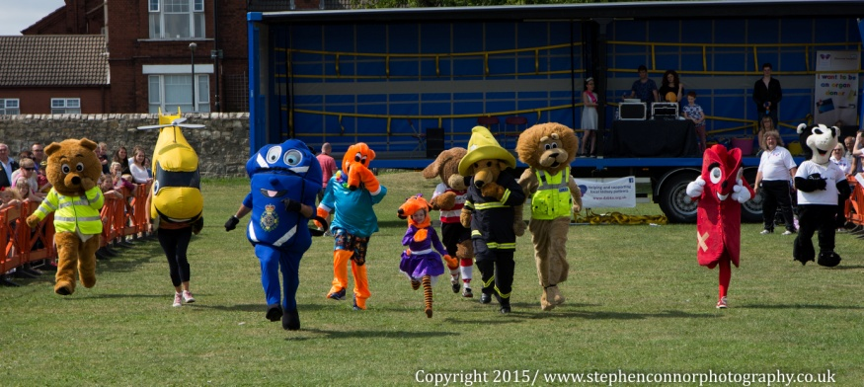
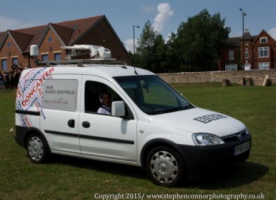
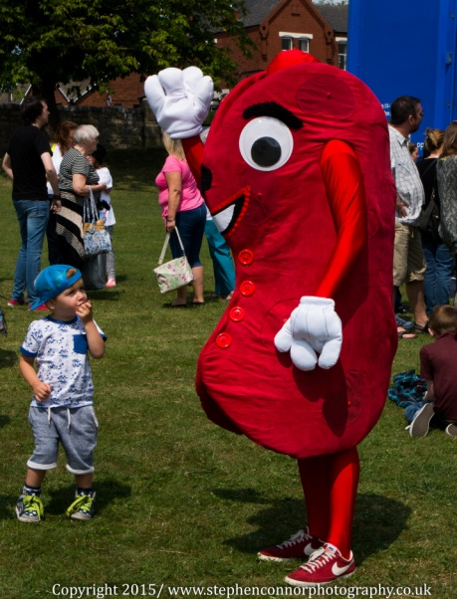
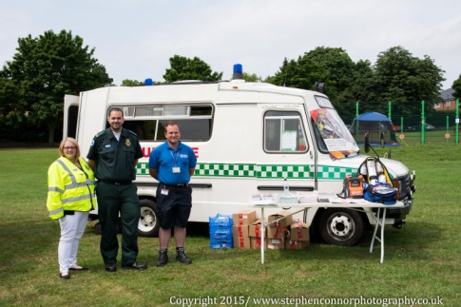
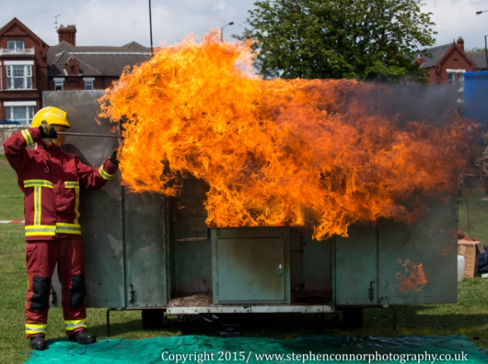
More photos can be found on our website www.dabka.org.uk
These photographs were kindly taken by Steven of Steven Connor Photography
Townfield Gala Raffle Results
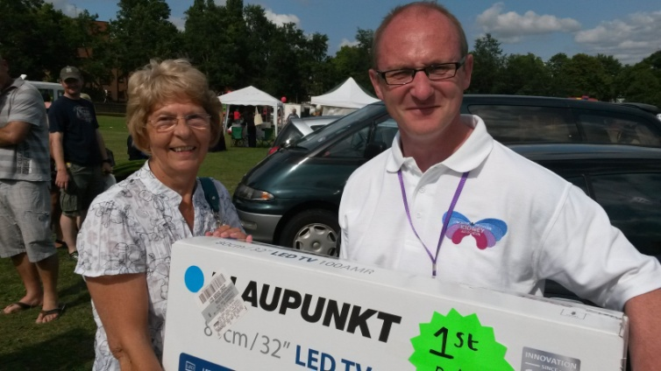
DaBKA Chairman Sean Starbuck presenting the 1st prize TV to Mrs Atack

Thank you to everyone who donated prizes for the tombola and raffle and those who purchased tickets

 | Prize | Winning Ticket | Winner
1st | 32ins HD TV | 1696 | Mrs Atack
2nd | Kindle Fire | 2751 | N Williams
3rd | Doncaster Rovers Tickets | 2365 | Mrs M Wraith
4th | George Forman Grill | 0062 | A Atmore
5th | Stanley Ratchet Set | 2838 | Mo
6th | 2 Vulcan Hanger Tickets | 2502 | G Fitz
7th | Yo-Unique Mascara & Eye-liner | 1694 | M Ford
8th | Britool 1/4in Drive set & Pen Light | 2743 | G Parker
9th | South Yorkshire Aircraft Museum Family Pass | 0298 | Stacey
10th | Stanley 39 pc Socket Set & Pen Light | 2725 | C Jacques
11th | South Yorkshire Aircraft Museum Family Pass | 0053 | Chris (DVDU)
12th | Swim & Skate Pass for 4 people at Dome | 2740 | L Jacques
13th | 1 Pair of Vue Cinema Tickets | 2710 | M Johnson
14th | Britool Rachet Screwdriver & Pen Light | 2316 | Stacey
15th | 1 Pair of Tickets for Doncaster Superbowl | 1262 | R Peel
16th | Purple Voucher Book & 2 Days Out Voucher Books | 2723 | C Jacques
17th | 1 Pair of Tickets for Doncaster Superbowl | 2317 | W Brown
18th | Teddy Bear & Bottle of Wine | 2852 | S Fletcher
19th | LFC Training Shirt & Football Shirt | 1261 | R Peel
20th | Black &Decker Power Screwdriver & Pen Light | 1706 | E Ross
21st | Stanley Fat Max 61 Pc Driver Set, Tool Box & Pen Light | 0296 | Stacey
22nd | Stanley Ratchet Screw Driver, Tool Box & Pen Light | 1291 | P Shinn
23rd | LED Laser Pen | 2278 | K Coates
24th | Stanley Fat Max 61 PC Driver Set, Tool Box & Pen Light | 2419 | Mick Wraith
25th | Britool Rachet Screwdriver & Pen Light | 0326 | M Flaguel
26th | Minion Toy | 1705 | Judy

Doncaster and Bassetlaw Kidney Association
Denise Holliday – Secretary 07444 281 141
Email: admin@dabka.org.uk
Web: www.dabka.org.uk

Doncaster Royal Infirmary:
Main Switchboard Number 01302 366666
Renal Outpatients 01302 647043
Ward 32 01302 647038
Haemodialysis Unit 01302 381455
Peritoneal Dialysis Nurses 01302 366666 ext. 4801
Debbie Starbuck 07770 748730
Pre-Dialysis 01302 366666 ext 3879
Claire Mitchell-Haynes 07920 085327

Bassetlaw Haemodialysis Unit: 01909 511 150

Dearne Valley Dialysis Unit: 01709 599 190

Sheffield Northern General:
Renal Assessment Unit 0114 271 5320
RUF Ward 0114 226 6391

Doncaster & Bassetlaw Kidney Association
Registered Charity number 1123780
6 Medley View
Conisbrough
Doncaster
DN12 2DT

